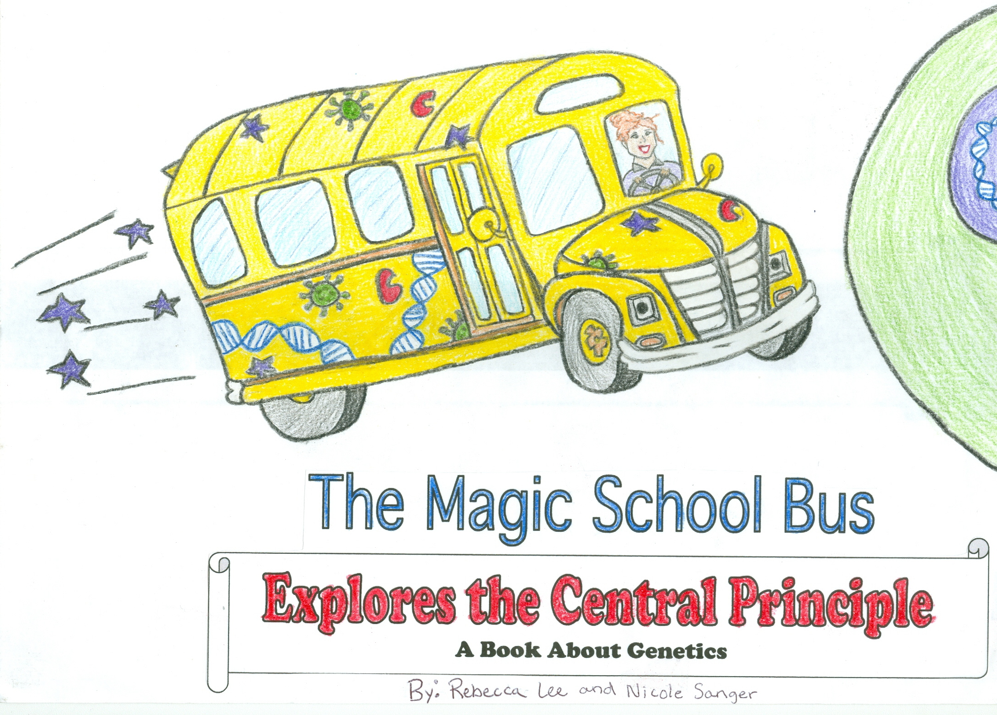
Having a teacher like Ms.Frizzle is always great. Not only is she zany, but she is also caring. This morning when we got to class, the Friz was taking attendance and noticed that Arnold was missing.
“Arnold?...Arnold? Oh dear, I believe Arnold is missing from class this morning!” exclaimed Ms. Frizzle.
At that moment the classroom phone rang. Ms. Frizzle answered.
“Hello, Ms. Frizzle speaking…Mmhmm….Oh goodness, thank you for letting me know. Goodbye.” Ms. Frizzle hung up the phone and turned to the class.
“I’m afraid Arnold is at home sick with a virus.” said Ms. Frizzle.
“What’s a virus?” asked Ralphie
“According to my research, a virus is a nonliving infectious agent that contains either RNA or DNA and is self replicating within a host cell.” answered Dorothy Ann.
“In English please.” retorted Ralphie.
“Well class the best way to understand a virus may be to see how it works.” said Ms. Frizzle.

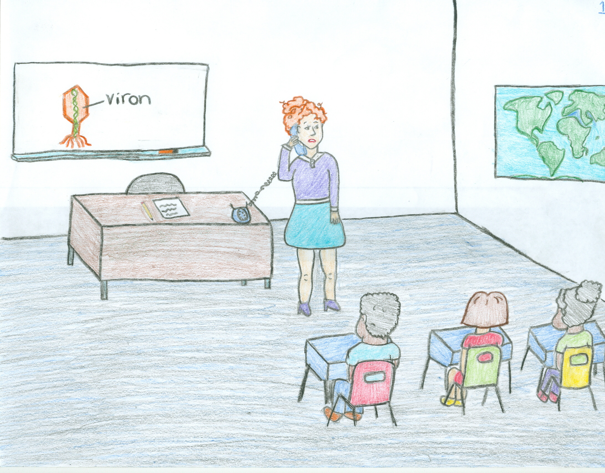
“To the bus!” shouted Ms. Frizzle. We filed out of the classroom buzzing with excitement. Ms. Frizzle’s field trips are as far from boring as you can get. We knew then that this was not going to be an ordinary day. After we loaded our bus, we set off for Arnold’s house.
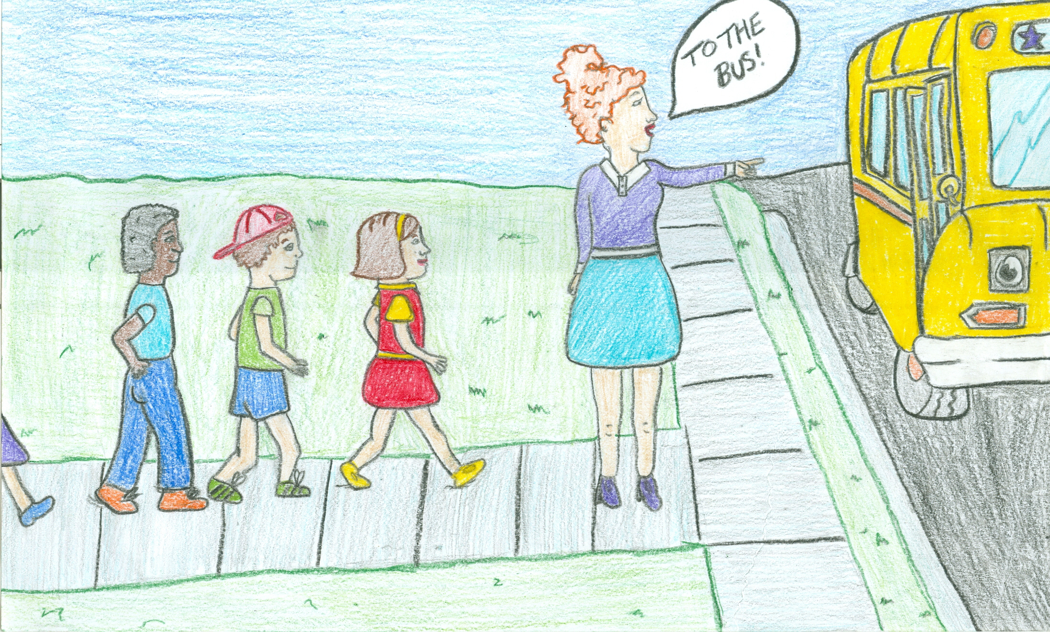
Arnold lay in bed coughing, fevered, and miserable. So many times he had wished to stay home from school in order to avoid Ms. Frizzle’s wacky field trips, but today this was not the case. Arnold was so sick he decided that no field trip could ever be this bad. Suddenly, Arnold saw Bus pull up to his house.
“Oh brother, just when I thought today couldn’t get any worse.” said Arnold. Then, Ms. Frizzle burst into his room.
“It’s your lucky day Arnold. We have decided to take a field trip inside your body to observe your virus!” exclaimed Ms. Frizzle.
“Yippy! My lucky day”, Arnold responded sarcastically.

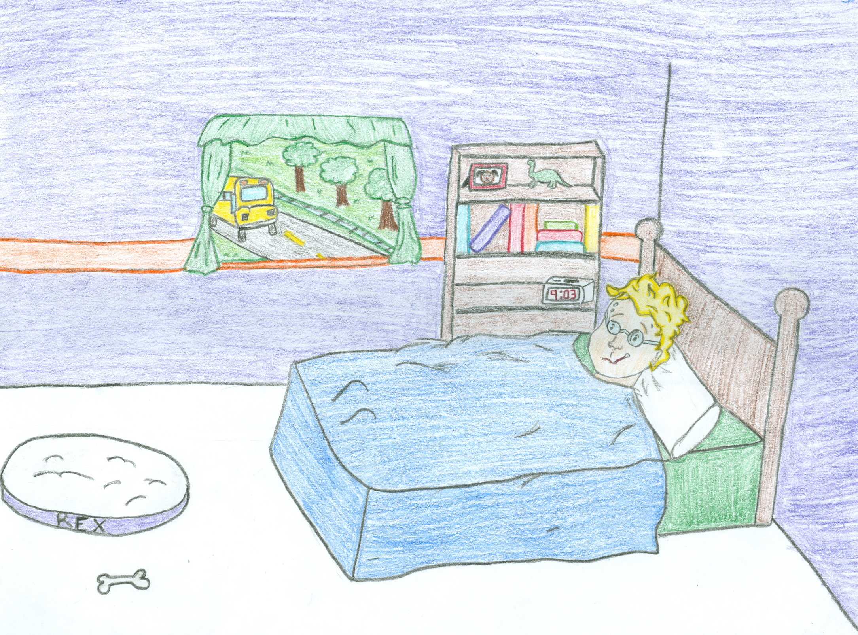
Ms. Frizzle got back on the bus.
“Like I always say kids, in order to learn you must take chances! Make mistakes! Get messy!” Ms. Frizzle cried.
The bus knew its cue and suddenly began to shrink. When it got to be about the size of a fly, wings sprouted out of the roof and it flew right up Arnold’s nose.

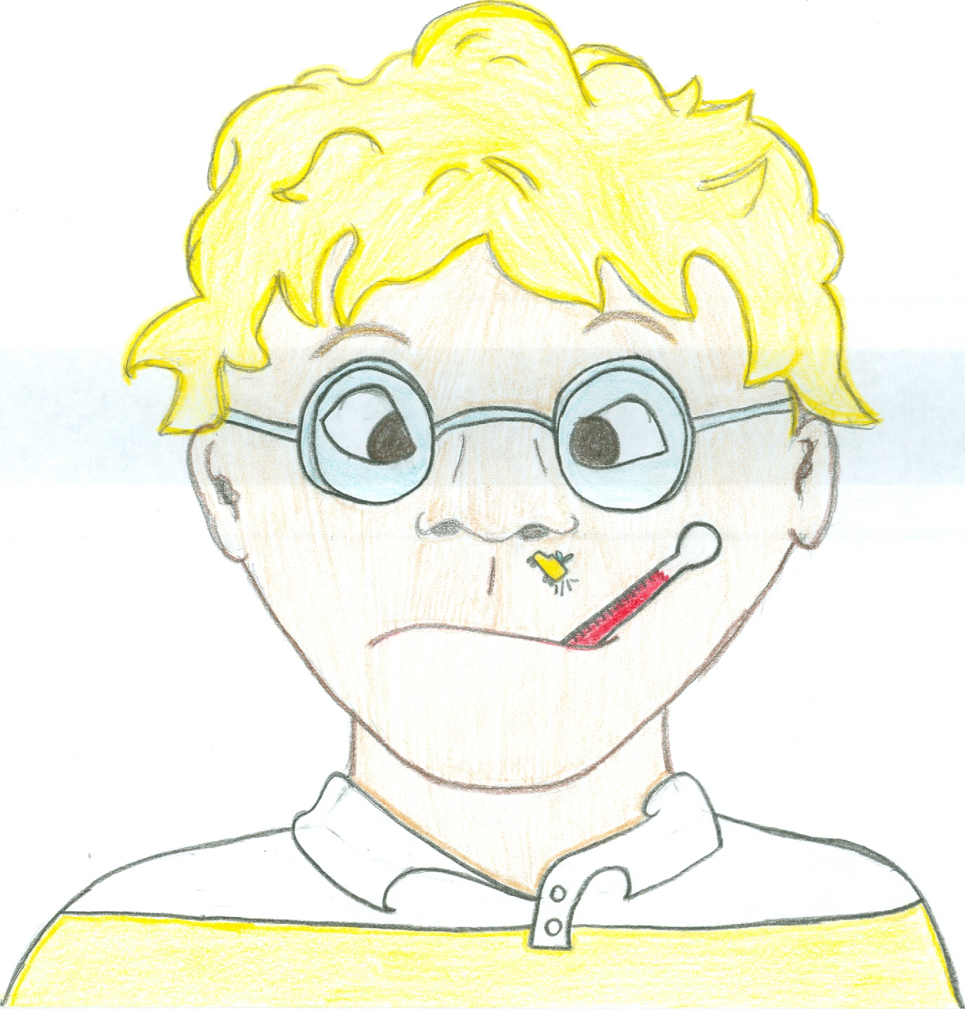

As Bus traveled deeper and deeper into Arnold’s body, it continued to shrink until it became microscopic. It then diffused into Arnold’s tissues.
“Look over there”, exclaimed Tim “What are those spiky spheres?”
“Well Tim, I believe those may be the virons responsible for making Arnold sick”, answered Ms. Frizzle.
“It looks like they are budding off of that cell over there.” said Dorothy Ann. “But why would Arnold’s cell be making more virons?”

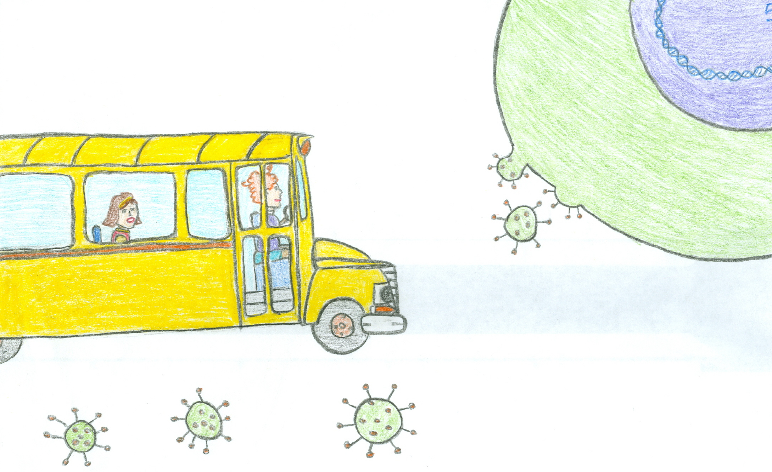
“A virus is a mischievous thing that takes advantage of the central principle of molecular biology by tricking the cell into becoming a factory for new virons”, explained Ms. Frizzle.
“Ms. Frizzle, what is the central principle of molecular biology?” asked Keesha.
“I’m glad you ask Keesha. The central principle of molecular biology is the pathway that cells use to transcribe DNA to RNA then translate RNA to proteins. Let’s go to the nucleus for a closer look.”
Bus thrusted through the plasma membrane of the cell and then drove through a nuclear pore to get into the nucleus.

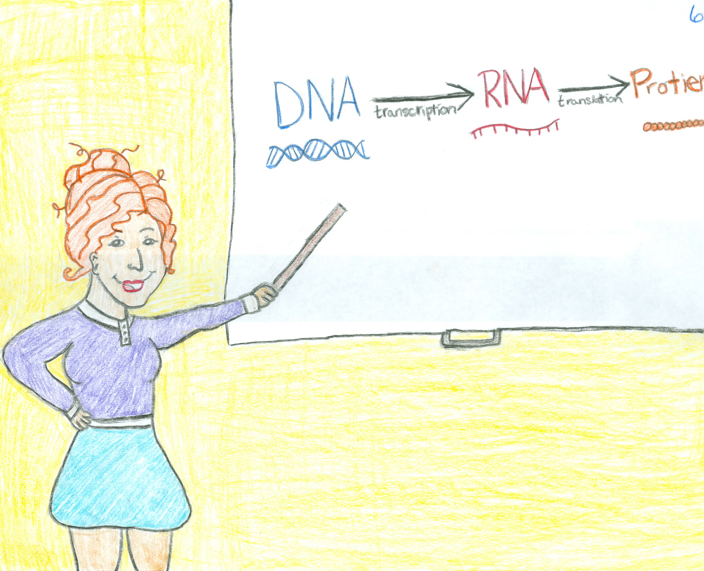
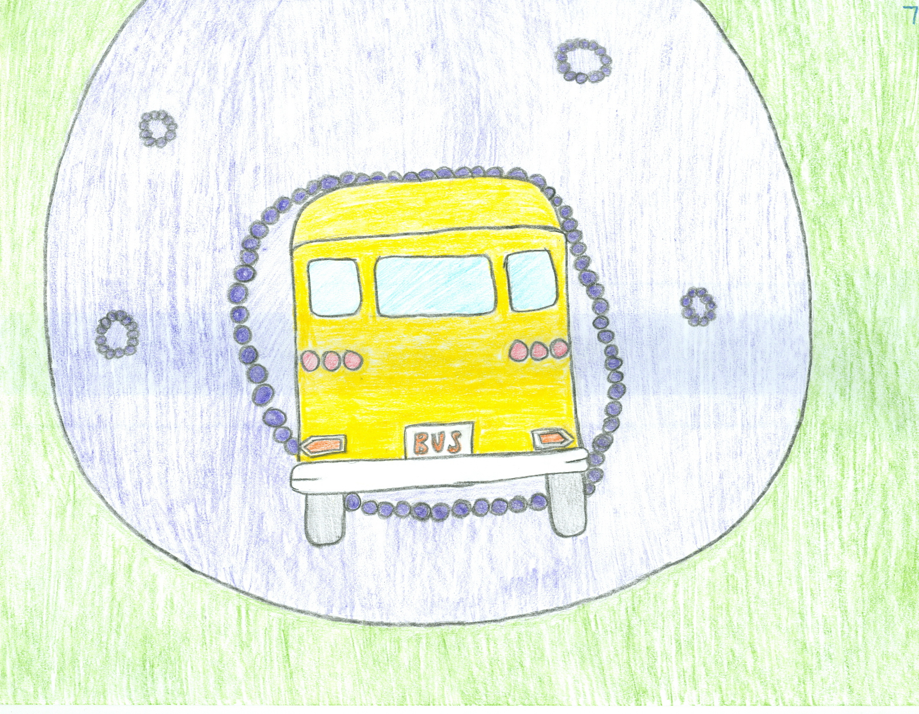
“Now that we’re in the nucleus we can see transcription up close. That enzyme there is called RNA polymerase it transcribes DNA into RNA. First, transcription factors will bind to a specific part of the DNA, called a promoter region, this tells the RNA polymerase where to attach itself to the DNA. Then the transcription factors will unwind the DNA and allow the RNA polymerase to make messenger RNA.” explained Ms.Frizzle.
“There goes the messenger RNA through the nuclear pore.” exclaimed Keesha.
“Let’s follow it to see what happens next.” said Ms.Frizzle.
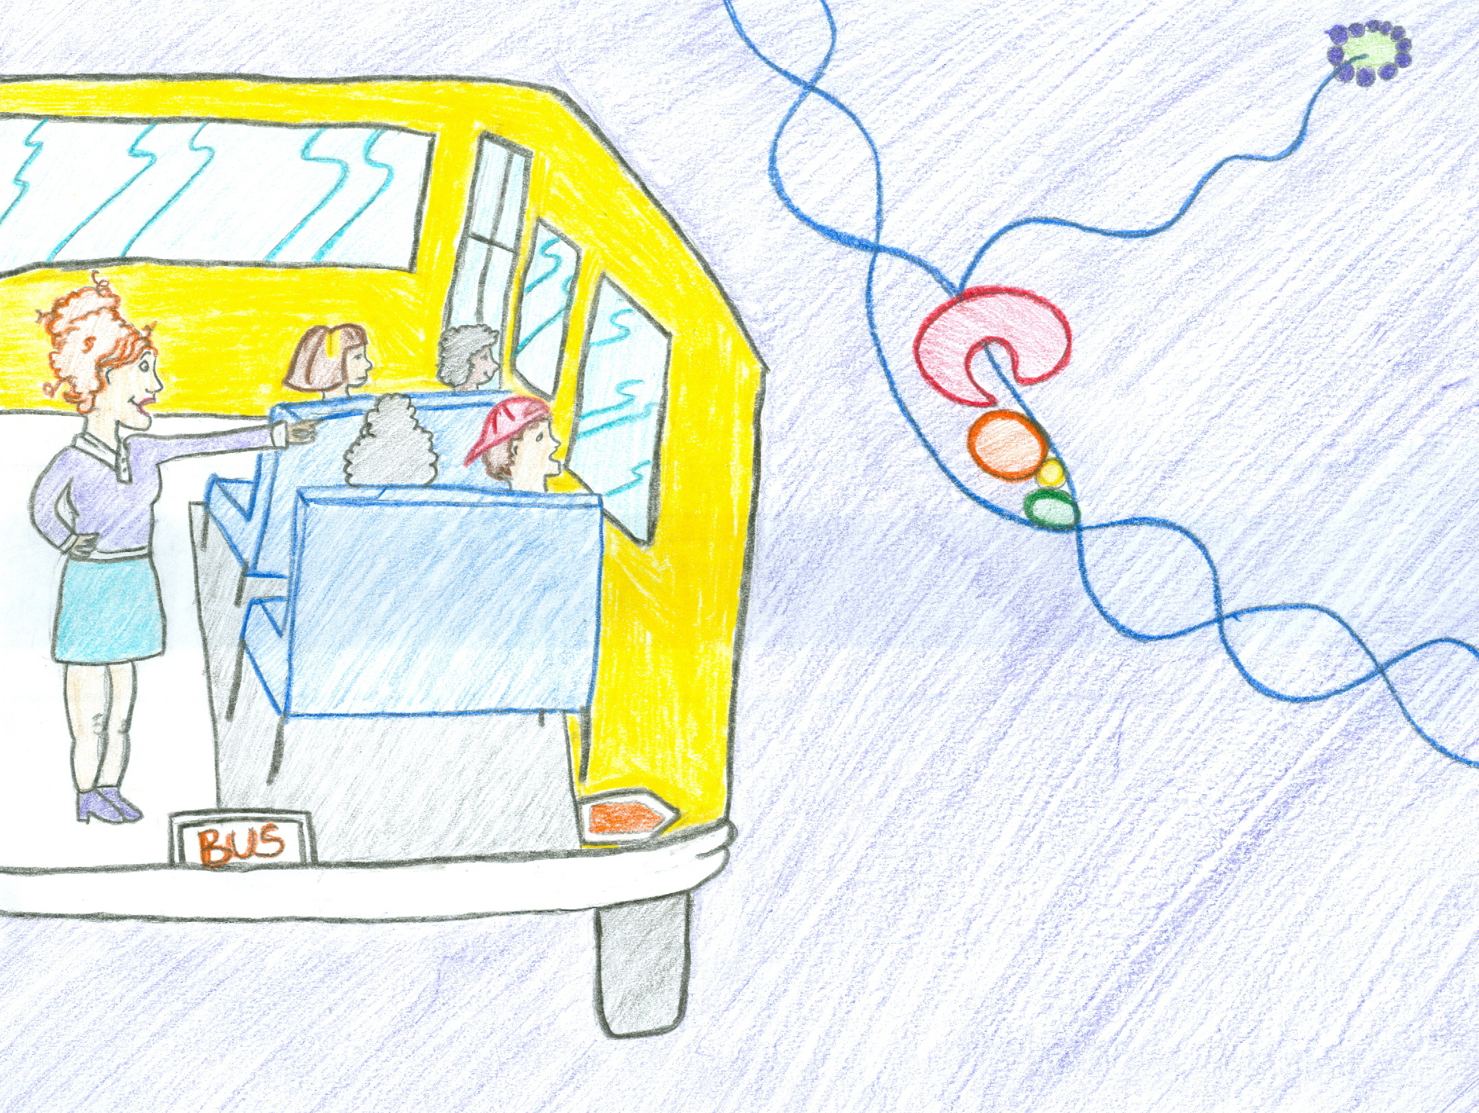

“Now that we are in the cytoplasm the messenger RNA can be translated into proteins. Proteins are made up of amino acids. The first step to translation is the binding of the ribosome to the end of the messenger RNA. Then transfer RNA molecules will bring specific amino acids to the ribosome so it can add them to the amino acid strand. When the Ribosome reaches the end of the coding region it runs into a portion of the messenger RNA that tells it to release from the messenger RNA.” explained Ms. Frizzle.

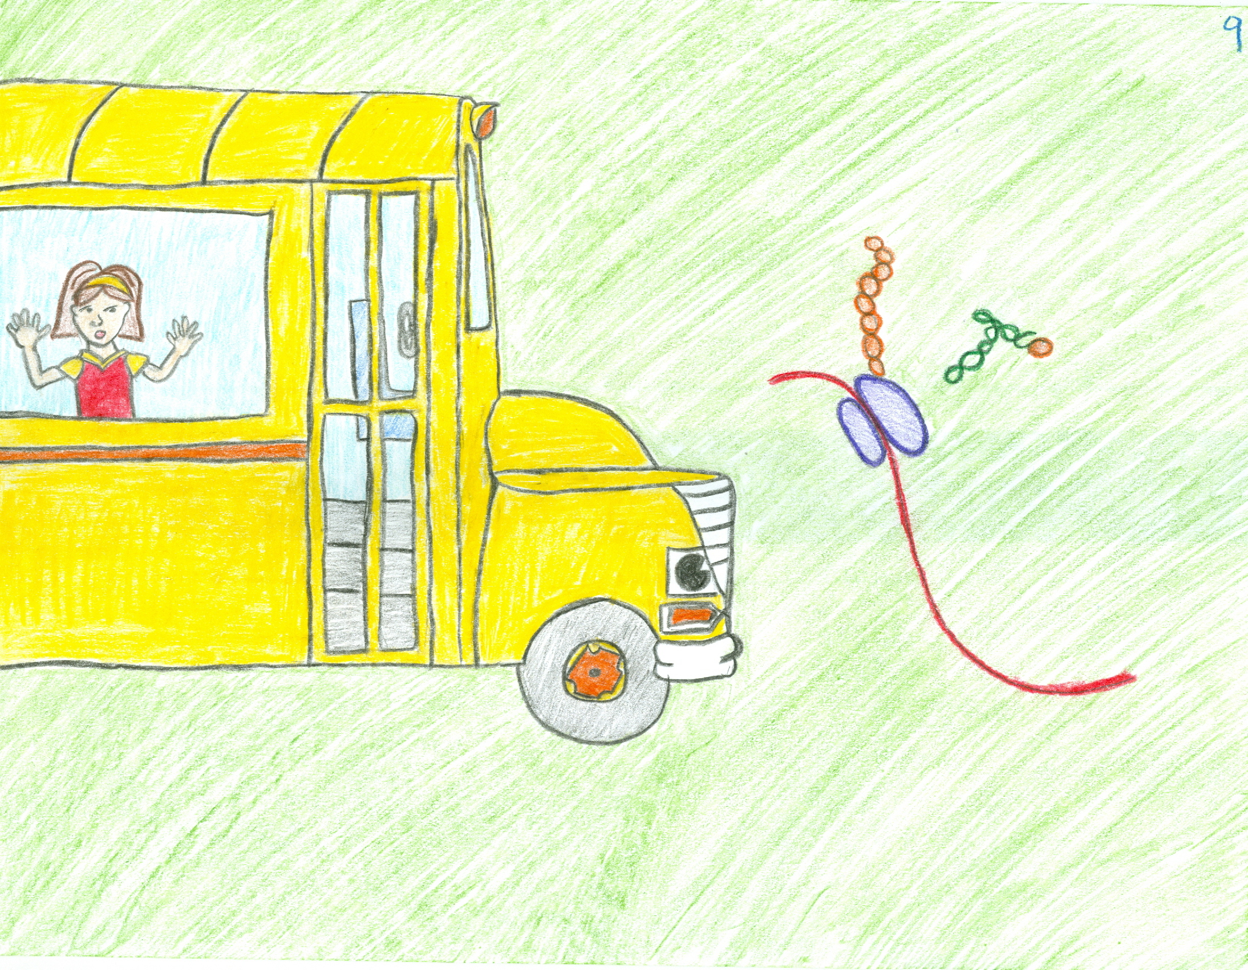
“So let me get this straight” stated Ralphie “Arnold’s cells mistake the virus DNA for its own and will transcribe that into mRNA, which leaves the nucleus and is then translated into new viruses?”
“Correct!” Exclaimed Ms. Frizzle
“So how can we get rid of the virus and make Arnold feel better so he can come back to class?” Asked Keesha
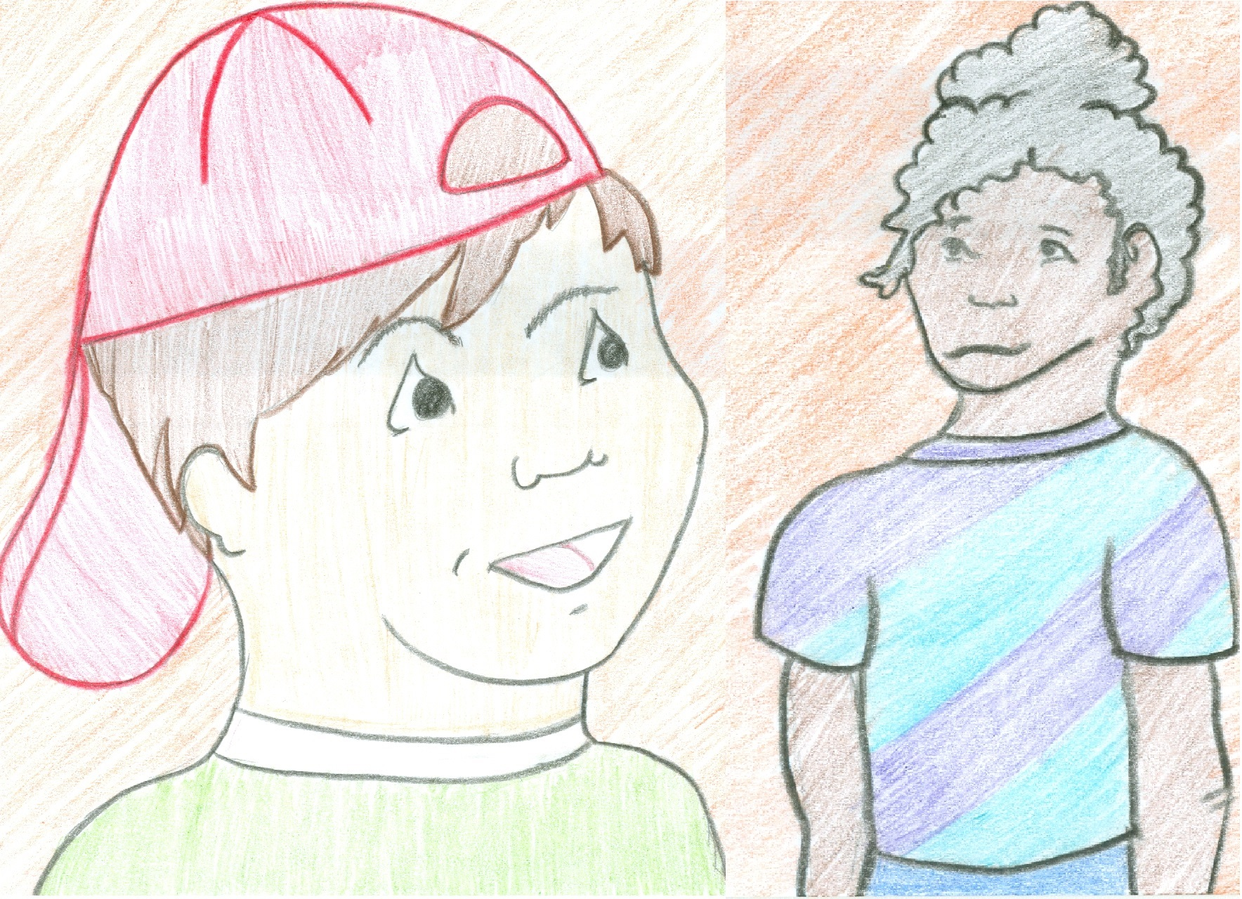
The students put on astronaut suits and filed out of the bus to fight off the nasty viruses.
“I think we got them all!” Tim shouted excitedly
Seeing that their mission was accomplished the students boarded the bus once again.
“Hold on tight kids, we’re heading home.” Said Ms. Frizzle as she directed Bus to leave Arnold’s cell

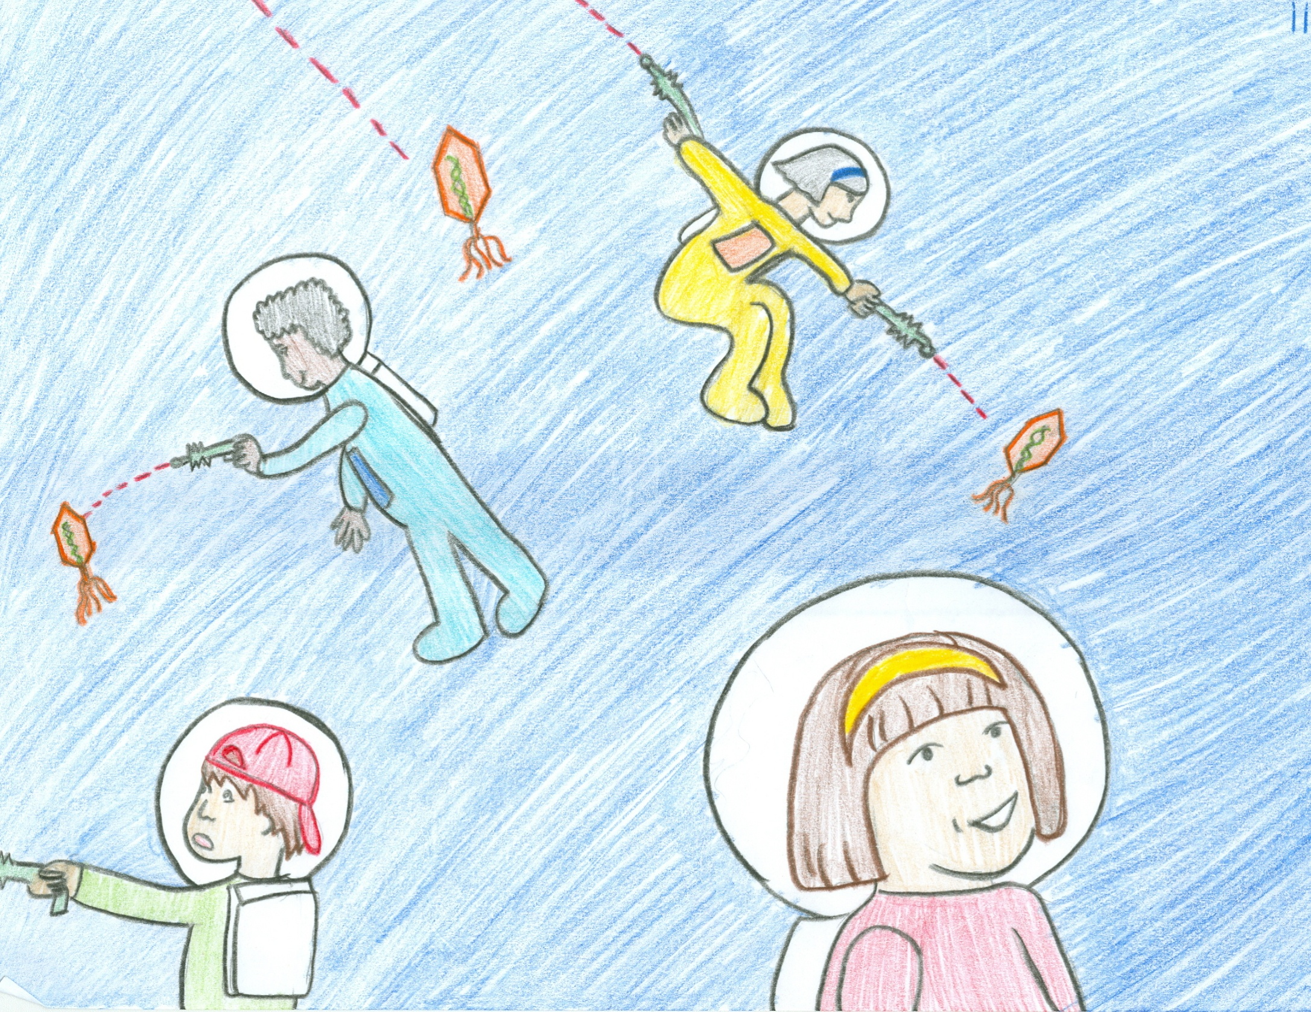

Bus left Arnold’s body the same way it had gone in. It flew out the window of Arnold’s room and began to grow. The class left the bus and collected in Arnold’s bedroom.
“How are you feeling Arnold?” Ms. Frizzle asked
“Much better!” Replied Arnold
“Great, get out of bed and onto the bus, we have another field trip to get to!” Ms. Frizzle said with a smile on her face
“Oh Brother” answered Arnold as he slowly climbed out of bed

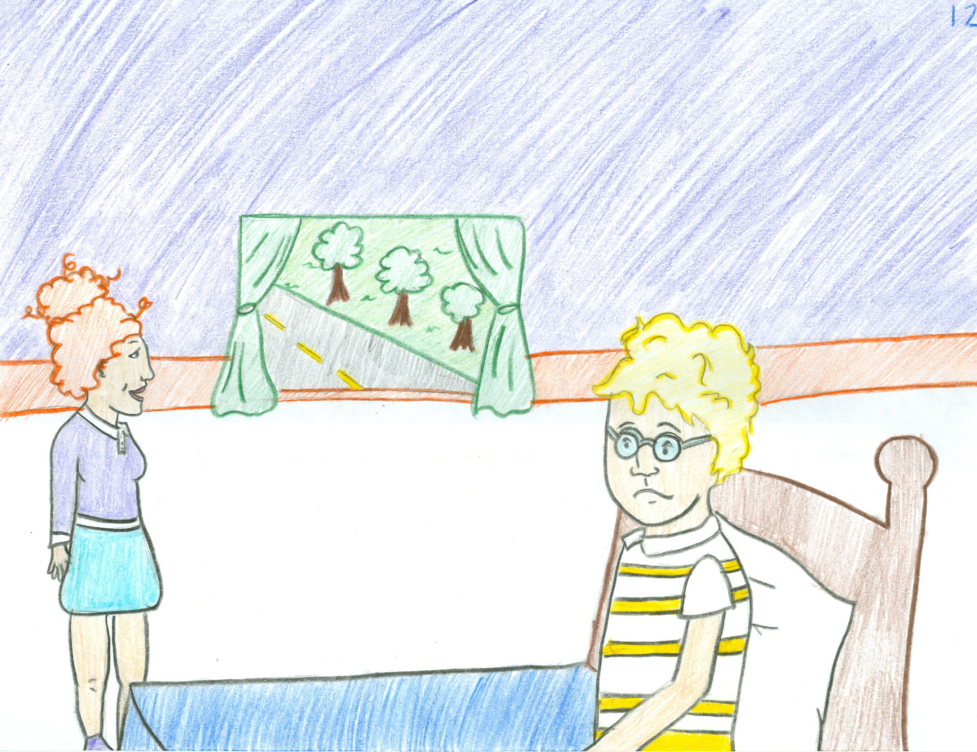

Literature Cited
1. Bailey, R. (2013). DNA Transcription. http://biology.about.com/od/cellularprocesses/ss/Dna-Transcription.htm
2. Bailey, R. (2013). Protein Synthesis-Translation. http://biology.about.com/od/cellularprocesses/ss/protein-synthesis-translation.htm
3. Cole, J. (1999). The Magic School Bus: Sees Stars. Print

